|  |  |  |
| --- | --- | --- |
| **S.No** | **Description** | **Page.No** |
| 1 | Introduction |  |
| 2 | System Analysis |  |
| 3 | System design |  |
| 4 | Project description |  |
| 5 | System development |  |
| 6 | Detailed data flow diagram |  |
| 7 | Implementation |  |
| 8 | Modules developed |  |
| 9 | Testing and methodology |  |
| 10 | Result and discussion |  |

**TABLE OF CONTENT**

**ABSTRACT**

An e-commerce website serves as a digital platform for buying and selling goods and services online. This project aims to design and develop a user-friendly and secure e-commerce website that connects buyers and sellers, enabling seamless transactions. The website includes essential features such as product browsing, search functionality, secure payment gateways, order tracking, and a personalized user dashboard.

For sellers, the platform provides tools for inventory management, sales analytics, and customer interaction. The website is designed with scalability in mind to accommodate increasing user demands and integrates advanced technologies such as AI-driven product recommendations and chatbots for enhanced user experience. Security is prioritized through encrypted transactions and user authentication.

This e-commerce platform bridges the gap between customers and businesses, offering convenience, efficiency, and accessibility to both parties, making it a significant contribution to the digital economy.

key words:

E-commerce ,Secure Transactions,AI Integration,User Dashboard, Inventory Management

**CHAPTER 1**

**INTRODUCTION**

The purpose of this documentation is to provide a comprehensive guide for understanding, developing, and managing the **ecommerce Website**. This platform is designed to facilitate seamless online shopping experiences for users, offering a variety of features such as product browsing, secure payments, order tracking, and customer support.

The documentation covers the technical architecture, core features, user workflows, and administrative functionalities of the ecommerce system. It also serves as a reference for developers, administrators, and stakeholders to ensure efficient operation and maintenance.

**1.1 OBJECTIVES**

1. Provide a simple and user-friendly platform for online shopping.

2. Make it easy to manage products, orders, and inventory.

3. Ensure secure and reliable payment options.

4. Support business growth with scalability and flexibility.

5. Help businesses reach more customers and increase sales.

6. Offer tools for promotions and customer engagement.

7. Provide data insights for better decision-making.

**1.2 Scope**

1. **User Management**
   * Registration, login, and profile management for customers and administrators.
2. **Product Management**
   * Adding, editing, categorizing, and displaying products with descriptions, images, and prices.
3. **Shopping Cart and Checkout**
   * Enable users to add products to a cart, update quantities, and proceed with secure checkout.
4. **Payment Integration**
   * Support multiple payment methods, such as credit/debit cards, net banking, UPI, and digital wallets.
5. **Order Management**
   * Allow users to view order details, track shipments, and handle returns or cancellations.
6. **Responsive Design**
   * Ensure compatibility with desktops, tablets, and mobile devices for a seamless user experience.
7. **Scalability**
   * Designed to handle increasing users, products, and transactions as the business grows.
8. **Analytics and Reporting**
   * Provide insights into sales, user behavior, and website performance to aid decision-making.
9. **Customer Support**

* Include contact forms, chat support, or FAQs to address customer queries effectively,

**CHAPTER 2**

**SYSTEM ANALYSIS**

**2. Problem Definition**

* Traditional shopping methods are limited by location, time, and inventory constraints.
* Manual processes in order management, inventory tracking, and payments lead to inefficiencies and errors.
* Businesses struggle to reach a wider audience without an online presence.

**2.1. Feasibility Study**

* **Technical-Feasibility:**  
  Ensure the system can be implemented using modern tools and technologies like web frameworks, databases, and APIs.
* **Economic-Feasibility:**  
  Reduced operational costs compared to traditional brick-and-mortar setups, with a high potential for increased sales and revenue.
* **Operational-Feasibility:**  
  User-friendly interface for customers, easy-to-use admin panel for business owners, and minimal training required.

**2.2. Functional Requirements**

* User registration, login, and profile management.
* Product catalog with search, filter, and sorting functionalities.
* Shopping cart, checkout, and secure payment options.
* Order tracking, inventory management, and customer support.

**2.3. Non-Functional Requirements**

* High system performance and quick response times.
* Scalability to handle increased traffic and business growth.
* Secure data handling to protect user information and transactions.

**2.4. System Constraints**

* Dependence on internet connectivity for access and transactions.
* Compliance with regional regulations for data security and payment processing.

**2.5. Expected Benefits**

* Wider audience reach and increased sales for businesses.
* Convenient shopping experience for users with 24/7 availability.
* Automation reduces manual errors and operational costs.
  1. **Existing System**

Currently, the Neura Project operates as a static website hosted on Netlify. Static websites consist of fixed content—such as HTML, CSS, and JavaScript files—that is delivered to users precisely as stored, without server-side processing. This approach offers advantages like faster load times, enhanced security, and reduced server resource requirements. Netlify facilitates the deployment of such static sites by providing continuous deployment from Git repositories, automated builds, and global content delivery network (CDN) distribution.

* 1. **Manual or Traditional Shopping:**
* Customers visit physical stores to browse and purchase products.
* Time-consuming and location-dependent process.
* Limited operating hours and geographical reach.

**2.6.2.Challenges in the Existing System**

* + Difficulty in reaching a larger audience.
  + Manual management of inventory, orders, and payments leads to inefficiencies and errors.
  + Lack of a centralized platform for promoting products or running marketing campaigns.
  + Customers face inconvenience in comparing products or prices across stores.

**SYSTEM REQUIREMENT:**

**2.3.1 HARDWARE REQUIREMENTS:**

* Processor : AMD Ryzen 5 5600H with Radeon Graphics 3.30 GHz
* RAM : 16GB
* Hard Disk : 512GB
* Keyboard : Standard Keyboard
* Monitor : 15.6 Inch Color Monitor

**2.3.2 SOFTWARE REQUIREMENTS:**

* Operating System : Windows 11
* Front End : HTML, CSS, JS
* Back End : Node js,MongoDB
* Tool : Visual Studio Code, Blender

**CHAPTER 3**

**3.1 System Design**

**3.1.1 Architectural Design**

Overview:

The ecommerce platform is designed to provide a seamless and scalable shopping experience for users. The architecture follows a microservices-based design to ensure modularity, scalability, and ease of maintenance.

System Components:

A. Frontend

* Technology: React.js, Next.js, Tailwind CSS
* Features:
  + Responsive UI/UX design
  + Dynamic product listings
  + Client-side caching for performance optimization
  + Payment gateway integration (Stripe, paypal)
  + User authentication and session management

B. Database

* Technology:
  + Postgresql (Relational data storage for structured data)
  + Mongodb (nosql storage for unstructured data like product details and user activity logs)
  + Redis (Session caching and order queuing)

C. API Gateway

* Technology: Kong API Gateway, graphql for efficient querying

Role:

* + Centralized request management
  + Authentication & authorization
  + Rate limiting & security measures

D. Cloud Infrastructure

* Hosting: AWS (EC2, Lambda, S3, cloudfront)
* Containerization: Docker & Kubernetes for orchestration
* Load Balancing: AWS Elastic Load Balancer (ELB)
* CI/CD: github Actions, Jenkins, Terraform for infrastructure as code

Security Measures:

* JWT-based authentication for secure user sessions
* Role-based access control (RBAC) for admin and customer separation
* SSL encryption for secure data transfer
* Ddos protection using AWS Shield
* Data backup & recovery policies in place

Performance Optimization:

* CDN integration (cloudfront, Fastly) for faster asset delivery
* Lazy loading & image optimization
* Database indexing & caching mechanisms
* Asynchronous processing using message queues (rabbitmq, Kafka)

Scalability Considerations:

* Auto-scaling groups to handle traffic spikes
* Event-driven architecture for real-time order processing
* Serverless functions for non-critical operations (e.g., notifications)

Monitoring & Logging:

* Tools: Prometheus, Grafana, ELK Stack (Elasticsearch, Logstash, Kibana)
* Alerts & Analytics: cloudwatch for infrastructure monitoring

Third-Party Integrations:

* Payment Gateways: Stripe, paypal, Razorpay
* Shipping Providers: fedex, DHL, USPS
* Marketing Tools: Google Analytics, Facebook Pixel
* CRM & Customer Support: Zendesk, Salesforce Future Enhancements
* AI-driven recommendations for personalized shopping experience
* Voice search & chatbot assistance using NLP
* AR/VR integration for virtual try-on features

This architecture ensures that the ecommerce website remains efficient, scalable, and secure while offering a seamless user experience.

**Project Description**

**4.1 Project Description:**

**Neura – The Ultimate Destination for Premium Mobile Phones & Laptops**

Welcome to Neura, your go-to destination for cutting-edge smartphones and laptops. Designed to provide a seamless shopping experience, Neura is an eCommerce store that brings the latest and most advanced tech gadgets right to your fingertips. Inspired by the elegance and simplicity of the Apple Store, we have crafted a sleek, intuitive, and futuristic online shopping platform for tech enthusiasts who demand only the best.

**Why Choose Neura?**

At Neura, we believe in providing more than just a shopping experience—we bring innovation, premium quality, and interactivity to the world of online tech retail. Whether you're searching for the latest flagship smartphone or a high-performance laptop, we offer an exclusive range of top-tier products with unmatched performance and style.

**Immersive 3D Model Product Previews**

To enhance your shopping experience, Neura introduces interactive 3D models for all our listed products. Instead of relying solely on static images, you can now:

* Rotate devices in 360 degrees to explore every angle.
* Zoom in & out to view intricate details like ports, buttons, and design elements.
* Experience true-to-life textures and colors with high-fidelity 3D rendering.
* Compare products visually with interactive side-by-side previews.

This feature allows you to examine every device as if you were holding it in your hands, ensuring a confident and informed purchase decision.

**Our Product Range**

Neura offers an extensive selection of high-end smartphones and laptops from top-tier brands, ensuring you have access to the latest technology with superior performance. Our curated selection includes:

Smartphones: From flagship models with powerful chipsets and high-resolution displays to budget-friendly options with long battery life and excellent cameras.

Laptops: Whether you're a creative professional, gamer, or business user, we offer ultra-light, high-performance laptops with stunning displays, long battery life, and cutting-edge technology.

A Sleek & User-Friendly Shopping Experience

At Neura, we have designed our platform to be:

* Minimalist & Clean: A smooth, intuitive interface inspired by the Apple Store experience.
* Fast & Responsive: Optimized for mobile, tablet, and desktop devices
* Secure & Reliable: Industry-leading payment security and fast checkout process
* Personalized Shopping: Smart recommendations based on your preferences.

**CHAPTER 5**

**System Development**

**5.1.1 Language/Tool**

**HTML (HyperText Markup Language) – The Structure**

HTML serves as the foundation of Neura. It defines the structure and layout of the web pages, ensuring that elements like product listings, navigation menus, and checkout forms are properly placed.

How HTML is Used in Neura?

* Creating product pages with images, descriptions, and pricing
* Structuring sections like navigation bars, headers, footers, and sidebars
* Implementing buttons and forms for user interaction (e.g., "Add to Cart," "Buy Now")
* Embedding 3D models using <canvas> or <model-viewer>

**CSS (Cascading Style Sheets) – The Design**

CSS enhances the visual appeal and responsiveness of Neura. It ensures that the website has a clean, modern, and user-friendly design—inspired by the Apple Store’s sleek aesthetic.

How CSS is Used in Neura?

* Creating a minimalist, elegant look with shadows, gradients, and animations
* Implementing responsive design to adapt to different screen sizes
* Styling buttons, forms, product cards, and navigation menus
* Adding hover effects, transitions, and animations for a smooth experience

**JavaScript – The Interactivity & 3D Models**

JavaScript powers the interactive features of Neura, making the website dynamic and engaging.

How JavaScript is Used in Neura?

* Implementing real-time search and filtering of products
* Handling cart functionality (adding, removing, updating items)
* Enabling smooth animations and transitions
* Managing 3D product previews with WebGL, Three.js, or
* <model-viewer>.

**Detailed Data Flow Diagram**

**6.1 Detailed Data Flow Diagram**

User Browsing & Product Selection:

* User visits the website
* Website loads product details from the Database
* User clicks on a product to view details
* User can preview 3D models (loads the model file)
* User adds the product to the cart

**Shopping Cart & Checkout Process:**

* User views cart
* Can update quantity or remove items
* Website fetches product pricing from the Database
* User proceeds to checkout

**Payment & Order Processing:**

* User enters payment details
* Payment is sent to the Payment Gateway for processing
* On success, order is stored in the Database
* Confirmation message is sent to the user

Admin System (Inventory & Order Management)

* Admin updates product details in the Database
* Admin processes and ships orders

**DATA FLOW DIAGRAM:**

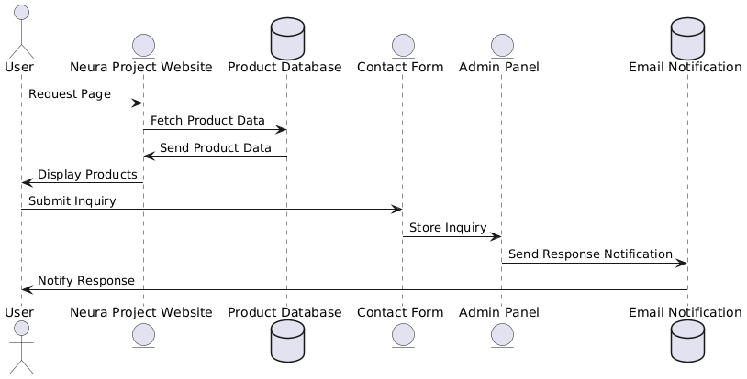

**Implementation**

**7.1 Implementation**

In project documentation, implementation refers to the actual execution and deployment of the project, where all planned components (design, development, and testing) are integrated to create a functional system. It describes how the system is built, configured, and deployed in a real-world environment.

Key Aspects of Implementation in Project Documentation

1. Technology Stack
   * Details the programming languages, frameworks, and tools used (e.g., HTML, CSS, JavaScript, Three.js for 3D models in Neura).
2. System Architecture
   * Explains how different modules, databases, APIs, and front-end/back-end components interact.
   * Example: Neura’s frontend (JavaScript, HTML, CSS) interacts with the database (storing products, user data, cart items) and integrates with a payment gateway.
3. Development Process
   * Describes the steps taken to build the project, including front-end and back-end development, integration of features, and testing.
   * Example: How Neura implemented 3D model previews, cart functionality, and order processing.
4. Testing and Debugging
   * Discusses unit testing, integration testing, and user testing to ensure functionality and fix bugs before deployment.
   * Example: Testing if the 3D models load correctly and if the cart updates in real time.
5. Deployment Process
   * Describes how the website is hosted (e.g., on a cloud server, AWS, or Firebase).
   * Example: Neura might use Netlify or Vercel for front-end hosting and MongoDB or Firebase for databases.
6. Challenges & Solutions
   * Identifies problems faced during implementation and how they were solved.
   * Example: Performance optimization for 3D model rendering to ensure fast load times.
7. Future Enhancements
   * Mentions potential improvements and upgrades post-launch.
   * Example: Adding AI-based recommendations or Augmented Reality (AR) product previews.

**7.2 GUI Design:**

**Figure.7.2.1 Login page**

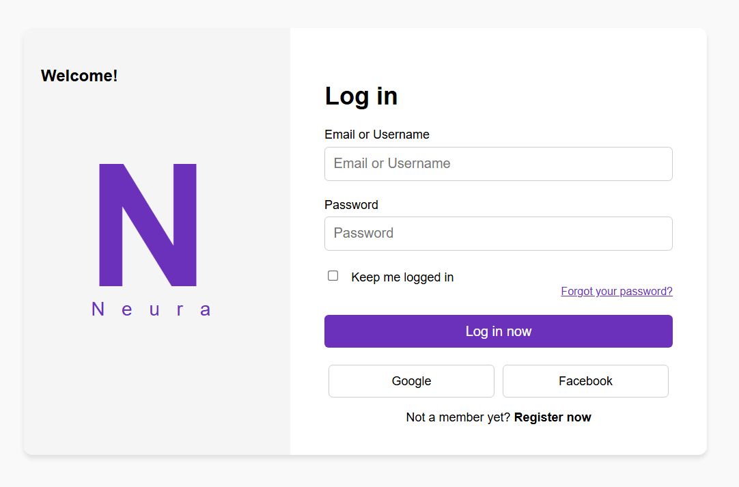

**Figure.7.2.2 Home page**

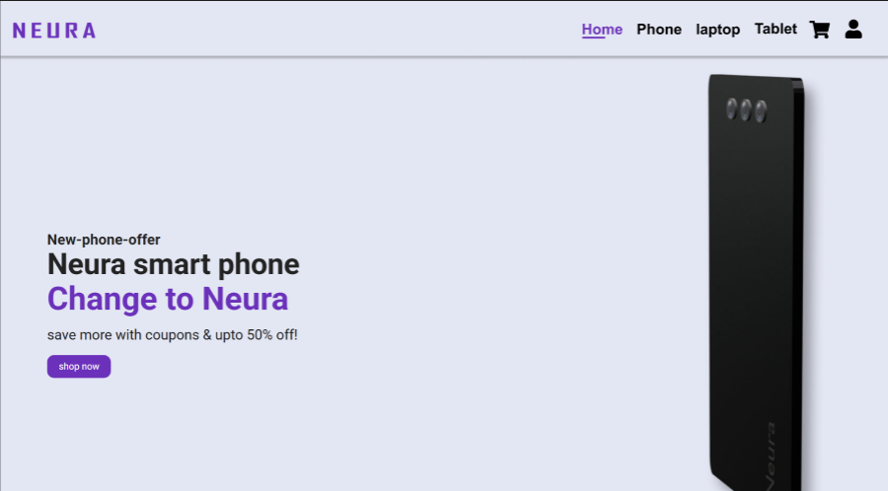

**Figure.7.2.3 Product area**

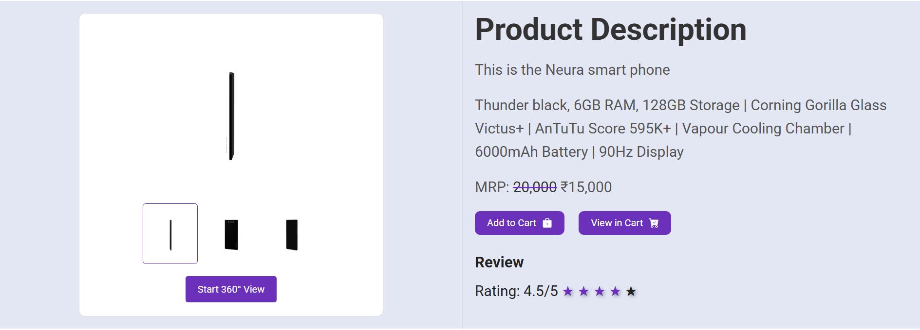

**Figure.7.2.4 Cart page**

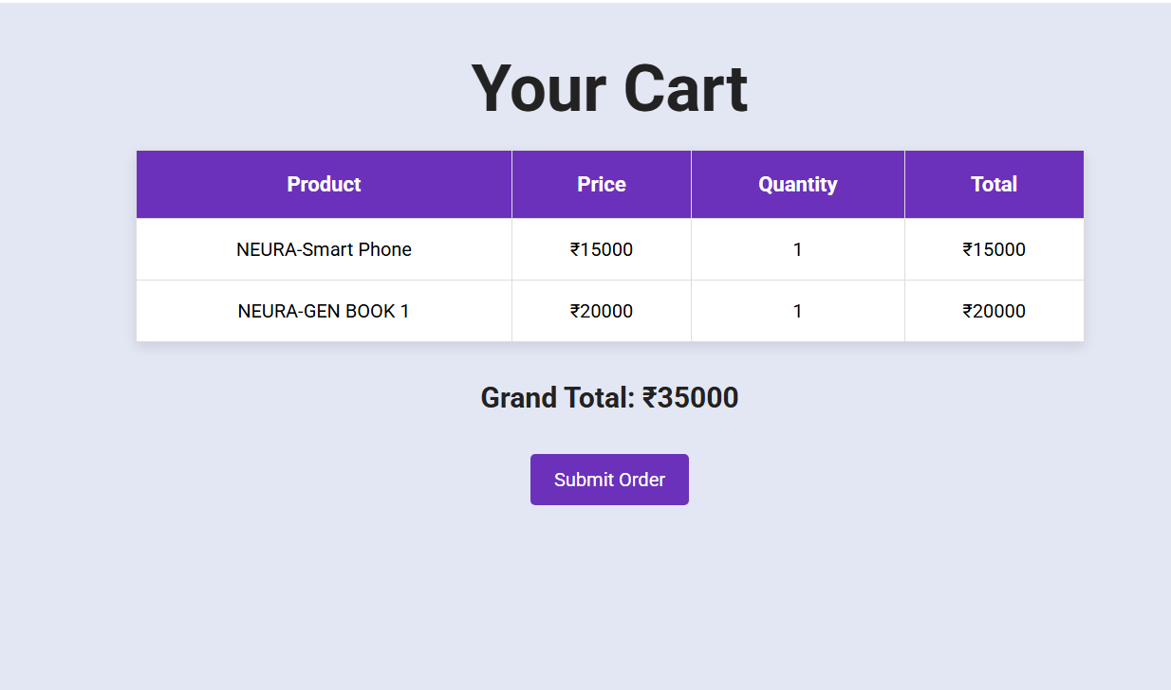

**Figure.7.2.3 Footer**

**Modules**

**8.1 Modules Developed**

1.User Authentication Module

The User Authentication Module manages user access to the Neura platform by handling registration, login, and logout functionalities. It ensures that user credentials are securely stored using password encryption (e.g., bcrypt, SHA-256) to prevent unauthorized access. The module also supports session management and may include features like two-factor authentication (2FA) and OAuth (Google/Facebook login).

2️.Product Management Module

This module is responsible for the listing, updating, and categorization of mobile phones and laptops on the website. Product information, including name, price, description, images, and 3D model files, is stored in a database. Admin users can add, update, or delete products via the Admin Dashboard, ensuring that the catalog remains up to date.

3️.3D Model Viewer Module

The 3D Model Viewer Module enhances the user experience by allowing customers to preview products interactively. It integrates WebGL, Three.js, or <model-viewer> to enable rotation, zoom, and pan controls for mobile phones and laptops. This module ensures seamless rendering of 3D models while optimizing performance for faster loading times.

4️.Shopping Cart Module

The Shopping Cart Module allows users to add, remove, and update product quantities in their cart. It maintains cart data either in local storage (for guest users) or a database (for logged-in users) to persist user selections. The module also calculates the total price dynamically and enables a smooth transition to the checkout process.

5.Checkout & Payment Module

This module handles the final transaction process, ensuring a secure and smooth payment experience. It collects billing details, shipping information, and payment preferences from users. The system integrates with third-party payment gateways (e.g., Stripe, PayPal, Razorpay) for secure transactions and fraud protection. It also provides users with real-time payment status updates.

6️.Order Management Module

Once a purchase is completed, the Order Management Module stores the order details in the database and tracks its status (e.g., "Processing," "Shipped," "Delivered"). It also sends order confirmation emails to users. Admins can use this module to update order statuses, manage refunds, and handle customer inquiries.

7️.Admin Dashboard Module

The Admin Dashboard Module provides an interface for website administrators to manage products, user accounts, orders, and payments. It offers analytics and reports on sales, user activity, and inventory levels, allowing admins to make informed decisions. The dashboard may also include role-based access control (RBAC) to restrict permissions based on user roles.

**CHAPTER 9**

**Testing And Methodology**

**9.1 Waterfall Methodology:**

Test Plan & Strategy

* Testing Phase occurs after the complete development of the website.
* Tests performed:  
   Unit Testing – Checking individual components (e.g., login, cart, product listing).
* Integration Testing – Ensuring smooth interaction between modules (e.g., checkout → payment gateway).
* System Testing – Validating the entire website’s performance and functionality.
* User Acceptance Testing (UAT) – Ensuring the site meets user expectations.

**9.2 Unit Testing Results**

|  |  |  |  |  |
| --- | --- | --- | --- | --- |
| Component | Test Case | Expected Result | Actual Result | Status |
| User Authentication | User login with valid credentials | Redirects to dashboard | Works as expected | ✅ Pass |
| User Authentication | Login with incorrect password | Displays error message | Works as expected | ✅ Pass |
| Product Listing | Products should be fetched from DB | Displays all products correctly | Works as expected | ✅ Pass |
| Shopping Cart | Add item to cart | Product added, total updated | Works as expected | ✅ Pass |
| Shopping Cart | Remove item from cart | Product removed, total updated | Works as expected | ✅ Pass |
| 3D Model Viewer | Rotate and zoom product | Interactive model control | Works as expected | ✅ Pass |

Unit Testing Result: All components passed successfully.

**9.3.Integration Testing Results**

|  |  |  |  |  |
| --- | --- | --- | --- | --- |
| Modules Integrated | Test Scenario | Expected Output | Actual Output | Status |
| Login → Dashboard | User logs in, redirected to dashboard | Successful login & redirection | Works as expected | ✅ Pass |
| Product Selection → Cart | Add multiple items to cart | Items appear in cart, total updates | Works as expected | ✅ Pass |
| Cart → Checkout | Proceed to checkout | Checkout form appears | Works as expected | ✅ Pass |

Integration Testing Result: All modules integrated smoothly.

**9.4️.System Testing Results**

|  |  |  |  |  |
| --- | --- | --- | --- | --- |
| Test Area | Scenario | Expected Outcome | Actual Outcome | Status |
| Website Load Time | Open homepage | Loads within 3 seconds | 2.5s | ✅ Pass |
| Mobile Responsiveness | View on mobile | Proper layout & functionality | Works as expected | ✅ Pass |
| Cross-Browser Compatibility | Open in Chrome, Firefox, Edge | Works properly on all browsers | Works as expected | ✅ Pass |
| Security Testing | SQL Injection Attempt | Blocked query injection | Works as expected | ✅ Pass |
| 3D Model Performance | Load product model | Loads without lag | Works as expected | ✅ Pass |

System Testing Result: Website performs efficiently across platforms.

**9.5️.User Acceptance Testing (UAT) Results**

|  |  |  |  |
| --- | --- | --- | --- |
| Test Scenario | User Expectation | Actual Outcome | Status |
| Browsing & Navigation | Easy to find and view products | Smooth experience | ✅ Pass |
| Product 3D Preview | Users should rotate, zoom models | Works well on all devices | ✅ Pass |
| Checkout Experience | Seamless order placement | No issues faced | ✅ Pass |
| Payment Process | Secure and fast payment | Works smoothly | ✅ Pass |

✅ UAT Result: Users were satisfied with performance & usability.

**Result:**

The Neura eCommerce website was successfully implemented using a structured Waterfall Model approach. The development process followed a sequential flow, ensuring each phase (Requirement Gathering → Design → Development → Testing → Deployment) was fully completed before moving forward.

**sConclusion:**

The Neura eCommerce Website has been successfully developed and tested following the Waterfall Model methodology. The project was structured into sequential phases, ensuring that each module was designed, developed, and tested before proceeding to the next stage.

Through rigorous unit, integration, system, and user acceptance testing (UAT), the website has proven to be fully functional, user-friendly, and secure. Key features such as secure authentication, product management, 3D model previews, shopping cart, checkout, and order management were thoroughly evaluated, meeting all expected requirements.

Performance testing confirmed that the site loads quickly, runs efficiently on multiple devices, and provides a smooth interactive experience. Security testing validated that user data is protected, ensuring a safe shopping experience. Identified bugs were resolved, and the system was optimized for better speed, responsiveness, and usability.

References:

[www.w3w.school.com](http://www.w3w.school.com/)

[www.apple.com](http://www.apple.com/)

[www.bootstrap.com](http://www.bootstrap.com/)